**# Lab1-2: Exploring Common Syntax Errors**

**Name: Abdul Hasib Zahid**

**University ID: 443058333**

**Answer to the Question No: 1**

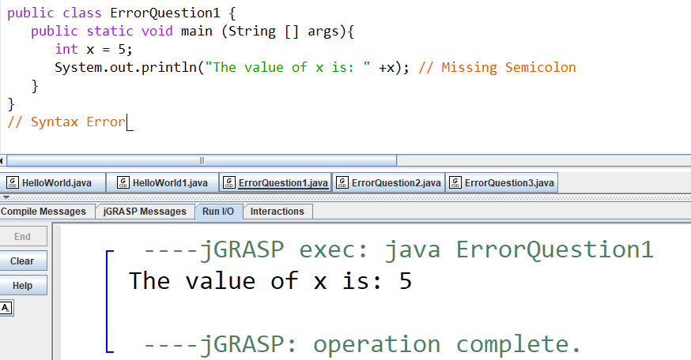

**Answer to the Question No: 2**

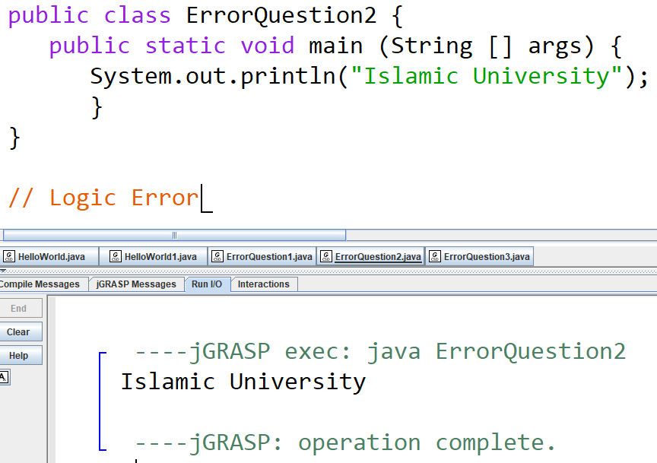

**Answer to the Question No: 3**

